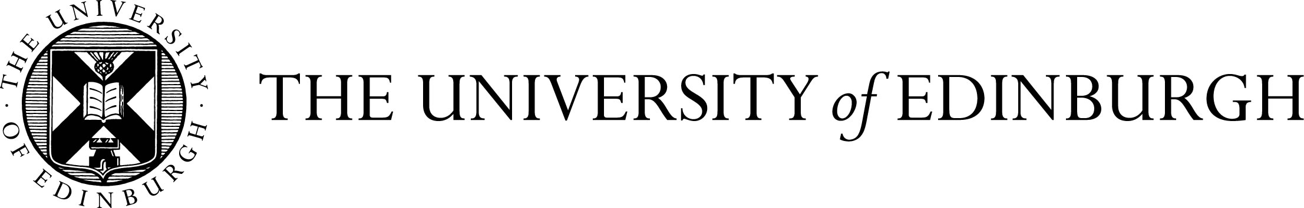The Princess Dashkova Russian Centre, 14 Buccleuch Place
24 -25 January 2013
Global Russian: Exploring New Research Perspectives International Symposium
Programme
Thursday, 24 January 2013
13:30-13:50 Registration
13:50-14:00 Welcome from Huw Lewis, Head of the Division of European Languages and Cultures
Panel 1. Chair: Ekaterina Popova (Edinburgh University)
14:00-14:30 Victoria Hudson (University of Birmingham), The Russkiy Mir: Easing Russia’s Way to Post-Colonialism?
14:30-15:00 Robert Saunders (Farmingdale State College, New York): “The Geopolitics of Russophonia: Language, Cultural Programs, and Nation Branding in Post-Soviet Space”
15:00-15:30 Vlad Strukov (Leeds University), “Russophone Television: Global Outreach versus Super Localisation”
15:30-15:45 Coffee
Panel 2. Chair: Aldona Judina (Edinburgh University)
15:45-16:15 Lara Ryazanova-Clarke (Edinburgh University): “Russian with an Accent: Globalisation and the post-Soviet imaginary”
16:15-16:45 Ekaterina Protassova (Helsinki University): “Global Russian in the Tourism Sphere”
16:45-17:00 Coffee
17:00-18:00 Keynote Lecture, Vladimir Alpatov (Russian Academy of Sciences), “Latin Alphabet for the Russian Language”
18:00 Drinks reception
19:15 Conference dinner: Elder Room, Old College, South Bridge
Friday, 25 January 2013
Panel 1. Chair: Lara Ryazanova-Clarke (Edinburgh University)
10:00-10:30 Aldona Judina (University of Edinburgh) “Evoking Russian and Soviet Cultural Knowledge: Linguistic Performance of ‘Russianness’ in everyday conversations among Russian-Speaking Families in Scotland”
10:30-11:00 Vera Zvereva (RGGU and University of Edinburgh) (by Skype) "Political communication in Russian Twitter: case study #Контрольнаяпрогулка"
11:00-11:30 Coffee
Panel 2. Chair: Samantha Sherry (Edinburgh University)
11:30-12:00 Matthew Ciscel (Central Connecticut State University): “From the Dniester to the Danube: Gradients of policy, proficiency, and practice in the Russian language”
12:00-12:30 Ammon Cheskin (Glasgow University): “The Russian language and Russian-speaking identity in Latvia”
12:45-14:00 Lunch
14:00-15:30 - Brainstorming Roundtable: ‘New Perspectives in the Study of Global Russian’


