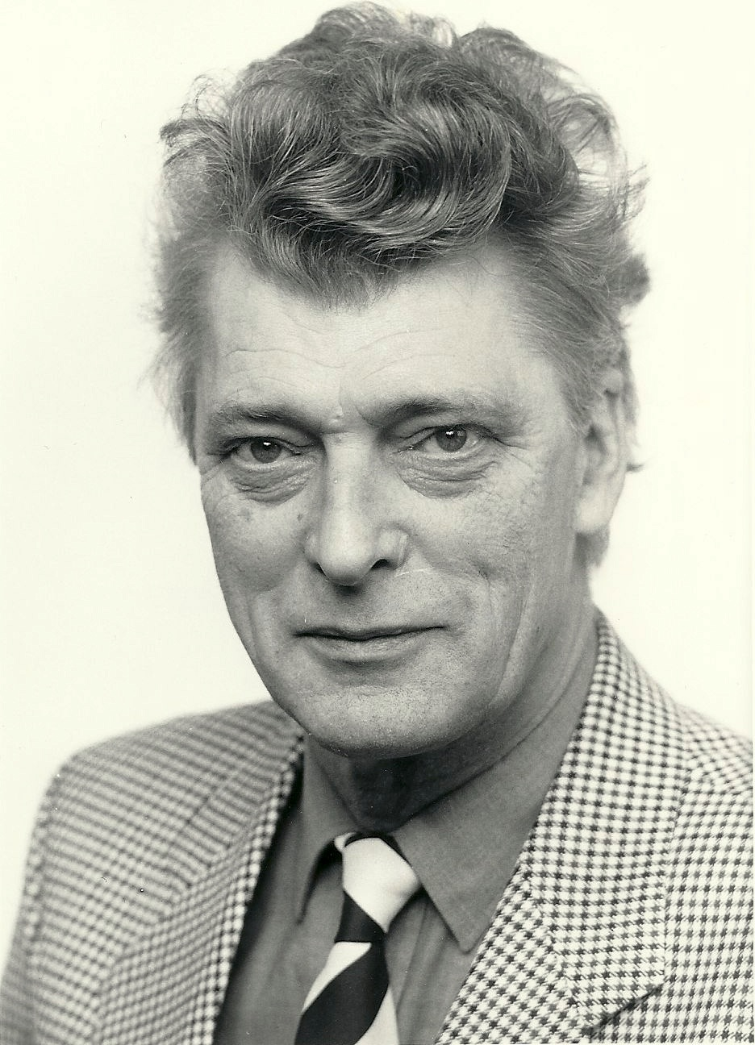
Professor John Erickson: Life and Work

Professor John Erickson, (1929-2002) was a British military historian, and the West’s leading authority on the Soviet military during and after the Second World War. During the Cold War, he was one of very few academics to win the trust of both sides and was at times a vital conduit for contact between the Americans and Soviets.

John Erickson was born on April 17 1929 at South Shields, Co. Durham. He had a genetic link to Russia: a Swedish forebear served in the Russian navy and served on the cruiser Aurora (which fired the blank shot signalling the assault on the Winter Palace in 1917). From South Shields High School, he served in the army in Yugoslavia before winning a scholarship to St John's College, Cambridge, to read History. After graduating, Erickson was a Research Fellow of St Anthony's, Oxford from 1956 until 1958. There he met his future wife, Ljubica Petrovic, a Yugoslav who was learning English. Erickson later worked at the universities of St Andrews, Manchester and Indiana before becoming a reader in higher defence studies at Edinburgh in 1967, where he remained for the rest of his career. He then became Professor of Politics (Defence Studies), and Head of the Centre for Defence Studies, and after retirement Emeritus Professor and Honorary Fellow.

Erickson’s most well-known book, the two-volume Stalin's War with Germany, incorporating The Road to Stalingrad (1975) and The Road to Berlin (1983), dealt with the Soviet response to the German invasion of the USSR. These volumes were acclaimed not just in the West but also by Soviet generals (several of whom asked Erickson to autograph their copies). They were perhaps the only historical work about the Soviet Union to be accepted as a classic in both West and East. The historian Norman Stone described the book as being ‘as close to being the definitive work on Soviet strategy, and military history, as it is possible to imagine.’

Erikson first visited the Soviet Union in 1963 as the research assistant for the American author Cornelius Ryan. Erickson's excellent Russian and knowledge of Soviet military history meant that he impressed and built up a rapport with Red Army leaders, including Marshals Koniev and Rokossovsky. Such high-level contacts afforded him repeated visits to Moscow, where the esteem in which he was held by the Soviet Academy of Sciences allowed him unique access to Soviet archives and generals.

Erickson’s influence in the Soviet high command reached its zenith in the 1980s, when he led what became known as the ‘Edinburgh Conversations.’ Initially, these were informal exchanges between prominent Scots and their Soviet counterparts. Later, they developed into complex discussions on arms control, related security issues and the environment. Dialogue alternated between Edinburgh and Moscow from 1981 to 1989. The first Soviet delegation, in 1983, included the editor of Pravda and two army generals. Despite increased East-West tensions in the early 1980s, Erickson’s insistence that ‘academic rules’ would prevail allowed them to continue in good spirit. The conversations gave each side in the Cold War a valuable insight into each other’s views, helped to thaw attitudes and influence official and academic thinking on both sides of the Cold War divide.

Erickson's other publications included Soviet Military Power (1971). He edited The Military Technical Revolution (1966), The Armed Forces and Society (1970), and Barbarossa, The Axis and the Allies (1994). His last book, compiled jointly with Ljubica Erickson, was The Eastern Front in Photographs 1941-1945 (2001). He wrote many academic and newspaper articles, and regularly spoke on radio and television. John Erickson was appointed a Fellow of the Royal Society of Edinburgh in 1982, and a Fellow of the British Academy in 1985. He and Ljubica donated their entire 7,000-volume collection of Soviet military materials and records to the National Library of Scotland.

The Erickson Lecture

The annual Erickson Lecture was established to mark the seminal contributions to military history and analysis made by John Erickson while Professor of Defence Studies at the University of Edinburgh. It acts as a platform for prominent analysts and politicians to discuss relations between Russia and the wider world. It is hosted by the University of Edinburgh Princess Dashkova Russia Centre, the University of Edinburgh Europa Institute and the University of Edinburgh Politics and International Relations Transatlantic Seminar Series. Previous speakers include Dr Vyacheslav Nikonov, President of the Polity Foundation and Executive Director of the Russkiy Mir Foundation, Professor Igor Yurgens, head of the Institute for Contemporary Development, Moscow, Lord George Robertson, Secretary General of NATO (1999-2004) and Sir Malcolm Rifkind, MP, UK Defence Secretary (1992-1995) and Foreign Secretary (1995-1997).

Selected Publications

- The Soviet High Command 1918-1941: A Military-Political History 1918-1941 (London: Macmillan, St Martin's Press, 1962)
- Panslavism (London: The Historical Association, 1964)
- The Road to Stalingrad. Stalin's War with Germany, Volume 1 (London: Weidenfeld & Nicholson, 1975)
- Soviet Military Power and Performance (edited by John Erickson and E.J. Feuchtwanger) (London : Macmillan, 1979)
- The Road to Berlin. Stalin's War with Germany, Volume 2 (London: Weidenfeld & Nicholson, 1983)
- The Soviet Ground Forces: An Operational Assessment (with Lynn Hansen and William Schneider) (Boulder, Westview, 1986)
- Main Front: Soviet Leaders Look Back on World War II (foreword by Marshal of the Soviet Union Sergey Sokolov; commentary by John Erickson) (London: Brassey's Defence, 1987).
- Barbarossa: The Axis and the Allies (edited by John Erickson and David Dilks) (Edinburgh: Edinburgh University Press, 1994)
- The Soviet Armed Forces, 1918-92: A Research Guide to Soviet Sources (edited by John Erickson and Ljubica Erickson) (Westport: Greenwood Press, 1996)
- The Eastern Front in Photographs: From Barbarossa to Stalingrad and Berlin (John Erickson and Ljubica Erickson) (London: Carlton Publishing, 2001)
- See also: Russia: War, Peace and Diplomacy: Essays in Honour of John Erickson (edited by Ljubica Erickson and Mark Erickson (London: Weidenfeld & Nicholson, 2004)

